1. Make changes in CureMD.config, Web.config of CureMD and Web.config of api.
   1. Config changes will depend on the type of branch, if it is from Live issues then url would contain release01 instead of baseline01. If the branch is from V10G like in the tutorial, then url would contain baseline01.



1. Convert api and CureMD to applications in IIS using their own application pools



1. Ensure the following settings in IIS:



Run the following command in cmd to stop iis (Run as administrator)

**iisreset –stop**



After copying all the contents, re-register objects in components then restart iis by executing the following line in cmd (Run as administrator)

**iisreset –start**





1. Open CureMD Project in Visual Studio, set branch release/baseline and build solution.
2. Open Architecture Project in Visual Studio, set branch release/baseline and build solution.
3. At this point, your api should browse successfully and basic functionality of your CureMD application should work fine

Try browsing the below urls:

* 1. <http://localhost/api> (This should show ERROR_CODE 1-000-0007)
  2. <http://localhost/CureMD/datLogin.asp> (Application should browse)

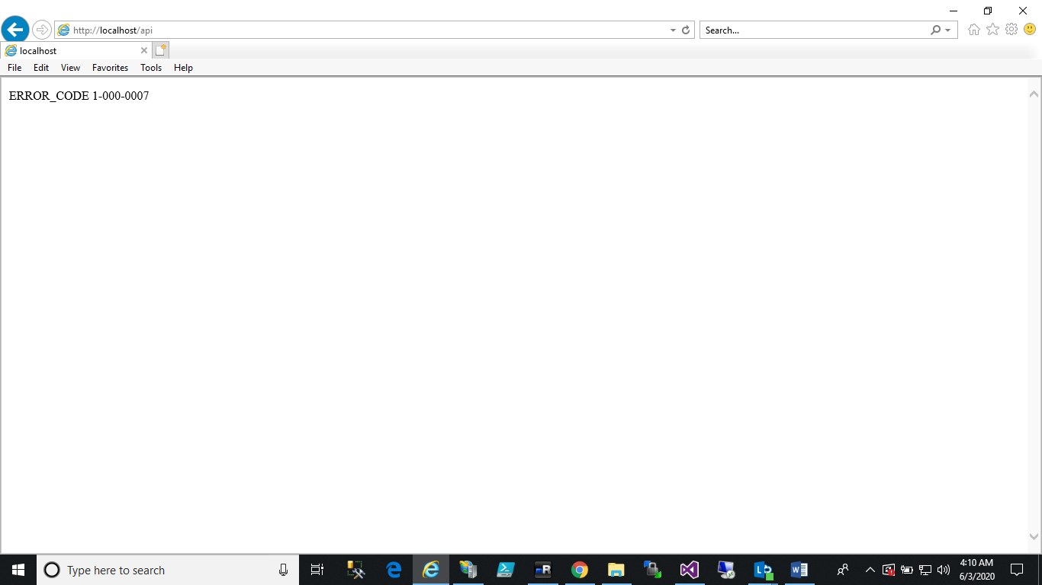

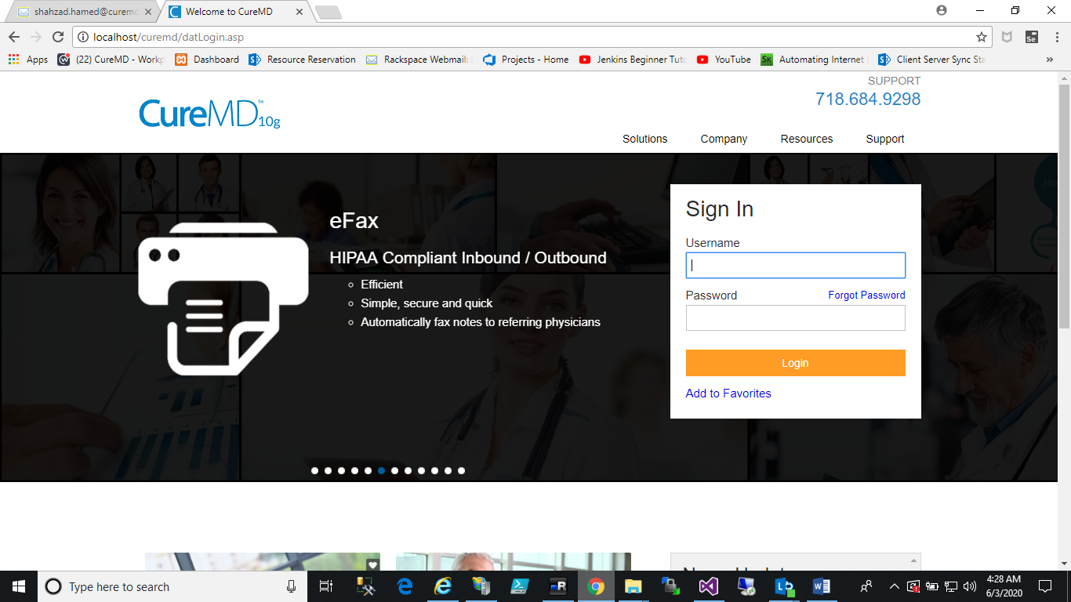

# Post Requisites

1. Also ensure that ASP.NET State Service is running

